**Sajid Ibna Mahbub** 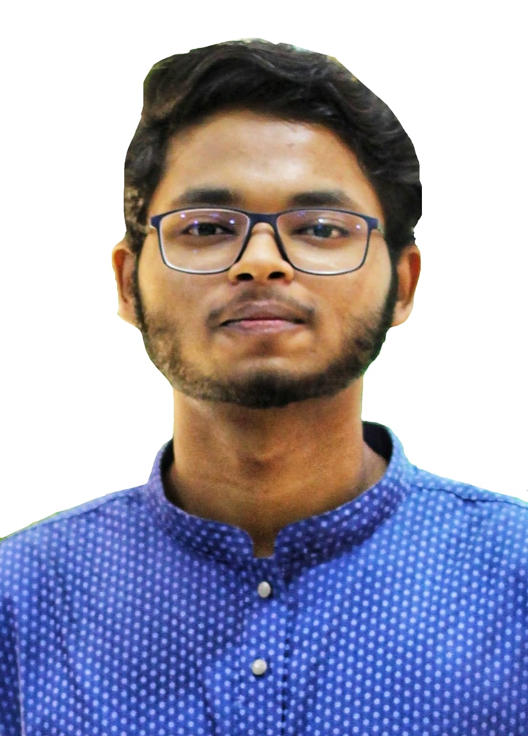

112/3, Shaplakanon

Rajarbagh, Sabujbag,

Dhaka-1214

Cell No: 01518439144

E-mail: sajid.mahbub40@gmail.com

**Objective:**

Attainment of maximum value and experience through offering well performance and interchanging benefit with the organization. I want to be a perfect working hand of the organization to attain its goal and to build up my career.

**Experience:**

1. Organization : Link3 Technologies Ltd

Position : Java Developer (Intern)

Company Location : Police Plaza, Gulshan, Dhaka

**Educational Background:**

**B.Sc Bachelor of Science**

Institution : American International University-Bangladesh

Discipline : Major in Software Engineering

Result (CGPA) : 3.85 out of 4.00 scales

Year of Passing : 2020

**HSC Higher Secondary Certificate**

Institution : Dhaka Imperial College

Group : Science (Dhaka Board)

Result (GPA) : 4.80 out of 5.00 scales

Year of Passing : 2017

**SSC Secondary School Certificate**

Institution : Ideal School and College, Motijheel, Dhaka - 1000

Group : Science (Dhaka Board)

Result (GPA) : 5.00 out of 5.00 scales

Year of Passing : 2015

**Key Personal Attributes:**

* Skilled in- Problem Analysis and Solving
* Loyal, Perseverant, Committed, and Believe in integrity & Perfection
* Team leading mentality
* Capability to work under pressure

**Competencies:**

* Disciplined and dynamic
* Energetic and enthusiastic
* Self-motivated and innovative

**Efficient In:**

* JAVA, J2EE, JSP and Servlet
* Object Oriented Analysis and design using common design patterns
* Tomcat
* Windows, Linux OS, macOS
* HTML, CSS
* MariaDB, PostgreSQL
* Database Management

**Language Skills:**

* Fluent in speaking and excellent at writing both Bengali and English

**Interests:**

* Sports, Programming, Singing, Reading Thriller Books, Solving Equations

**Personal Information:**

Father’s Name : S. M. Mahbubur Rahman

Father’s Occupation : Senior Executive Officer

SONALI BANK LTD, Head Office, Dhaka-1000

Mother’s Name : Beauty Rahman

Mother’s Occupation : Housewife

Date of Birth : 29th January, 1998

Religion : Islam

Marital Status : Single

**Extra Curriculum Activities:**

* Participated in different cultural and sports program in School, College & University level.
* Organized Data Mania 2020
* Worked as a volunteer at UNESCO

**References:**

**Md. Shoaib Ali Md. Abu Sufian Sarkar**

General Manager (Rtd) Head of HR & Admin

BANGLADESH BANK RAHIMAFROOZ DISTRIBUTION LTD. Globe Chamber, 104 Motijheel C/A,

Head Office, Motijheel C/A Dhaka-1000, Bangladesh

Dhaka-1000, Bangladesh Cell: +8801766246620

Cell: +8801832385560



**Sajid Ibna Mahbub**